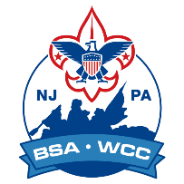
The Washington Crossing Council is committed to providing training to better prepare Cub Scout leaders. To make training more accessible, WCC will be offering multiple in-person training courses, in addition to the online training available.

Three Steps to Becoming a Trained Leader
- Set up a My.Scouting account
- Take Youth Protection Training and submit your adult application to be approved by your chartered organization.
- Take “Position Specific” training. Once you are registered go to the BSA Learning Center accessed via My.Scouting. Select your position and a learning plan will be created for you. The plan includes modules that are designed to allow you to complete them at your own pace.
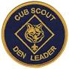
Online Position Specific training for Cub Scout leaders:
- Den Leader & Assistant Training (125 minutes)
- Cubmaster & Assistant Training (117 minutes)
- Pack Committee Chair Training (116 minutes)
- Pack Committee Member Training (53 minutes)

Washington Crossing Council realizes that online courses are not for everyone.
Benefits of in-person training:
- Ability to meet other leaders.
- Ask questions or ask for clarification.
- Share ideas.
- Provide a quiet place to concentrate and/or focus. (*childcare will be provided)
- Resources for more information. (Please realize Facebook has a lot of misinformation.)
Planned In-Person Training Locations for Fall 2024:
- Prince of Peace Lutheran Church
177 Princeton-Hightstown Road, Princeton Junction, NJ 08550
- Washington Crossing Council, Scout Service Center
1 Scout Way, Doylestown, PA 18901
- St John's Evangelical Lutheran
1203 Pine Grove Road, Yardley, PA

If your pack is interested, and can provide training space, WCC trainers will come to your location and provide in-person Cub Scout leader training. Contact the training professional advisor, Janet L. Boris, at janet.boris@scouting.org.
Use the QR code to access the WCC Den Leader training page.
Registration links will be listed as they become available.

